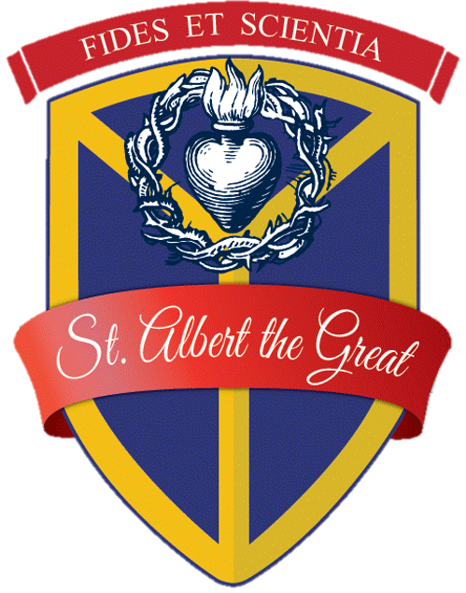

St. Albert the Great Academy Job Posting

St. Albert the Great Academy, a private Catholic elementary school, is currently seeking a Vice Principal who will serve a significant role in supporting, promoting and enriching the mission of St. Albert’s in word and witness. In this role you will work in conjunction with the Principal to focus on the continuing development and implementation of an academic program that promotes the greatness of mind, body and spirit. This call to lead, inspire and build a community of students and their families is one that if answered, offers boundless rewards.

About Us: St. Albert the Great Academy, located in Auburn NY, is a PreK - 6 Independent Catholic School. St Albert’s is chartered by the New York State Department of Education and meets both NYS standards as well as the benchmarks of a Catholic Liberal Education. By collaborating with parents and guardians as the primary educators, we prepare our students both socially and intellectually for their next level of learning. As witnesses to Gospel truths, our teachers foster a culture of joy in learning, confidence in ability, and love of neighbor.

Qualifications:
- Embody Catholic values in both faith and practice.
- Possess excellent communication, organizational and interpersonal skills
- Willing to embrace St. Albert’s curriculum content, mission and identity.
- Have a teacher’s certification and a Master’s degree in education and/or graduate degree in administration. Those who do not currently possess these criteria, but are supportive of working towards our mission are encouraged to apply.

Applicants must submit a completed job application, cover letter, resume and Letter of Good Standing from your parish to info@stalbertacademy.org

Applications may be found on our website at www.stalbertacademy.org

Position: Vice Principal

Reports to: Principal of St. Albert the Great Academy

Compensation Range: $65,000-$75,000

