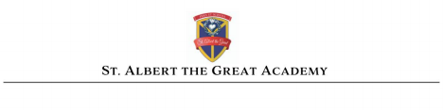Position: Classroom Teacher
Reports to: Principal of St. Albert the Great Academy
Job description: St. Albert the Great Academy seeks educators committed to teaching the whole child in the Catholic tradition.
St. Albert the Great Academy is a PreK - 6 Independent Catholic School chartered by the NY State Department of Education. St. Albert the Great students learn to write well, read well, and think well in a program that emphasizes classical learning and values moral formation as part of the learning process in all subject areas. Our academic program follows standards laid out by the NYS Department of Education and benchmarks of a Catholic Liberal Education which sets us apart in our Catholic identity and academic rigor. Our students are prepared well socially and intellectually for higher levels of learning. Our teachers guide students from all different abilities to achieve their highest potential by respecting the natural development of children. As witnesses to Gospel truths, our teachers foster a culture of joy in learning, confidence in ability, and love of neighbor. Parents grasp the value of this deeply human formation that nurtures the souls, not just the minds, of their children.
Beautiful indeed and of great importance is the vocation of all those who aid parents in fulfilling their duties and who, as representatives of the human community, undertake the task of education in schools. This vocation demands special qualities of mind and heart, very careful preparation, and continuing readiness to renew and to adapt.
(DECLARATION ON CHRISTIAN EDUCATION GRAVISSIMUM EDUCATIONIS #5)

Qualifications: A Bachelor’s Degree in Education or specific content areas is preferred. Experience in the classroom is preferred but not required. A willingness to learn and understand curriculum content, mission, and identity of St. Albert the Great Academy.
Applicants must submit a completed job application, a cover letter stating why you would like to be a teacher at St. Albert the Great Academy, and your resume/curriculum vitae. Documentation should be emailed to info@stalbertacademy.org.

